Data Structure and Algorithm

Laboratory Activity No. 6

Singly Linked Lists

|  |  |
| --- | --- |
| *Submitted by:* | *Instructor:* |
| Ramos, Jan Lawrence M. | Engr. Maria Rizette H. Sayo |

August 23, 2025

# Objectives

Introduction

A linked list is an organization of a list where each item in the list is in a separate node. Linked lists look like the links in a chain. Each link is attached to the next link by a reference that points to the next link in the chain. When working with a linked list, each link in the chain is called a Node. Each node consists of two pieces of information, an item, which is the data associated with the node, and a link to the next node in the linked list, often called next.

This laboratory activity aims to implement the principles and techniques in:

* Writing algorithms using Linked list
* Writing a python program that will perform the common operations in a singly linked list

# Methods

* Write a Python program to create a singly linked list of prime numbers less than 20. By iterating through the list, display all the prime numbers, the head, and the tail of the list. (using Google Colab)
* Save your source codes to GitHub

# Results

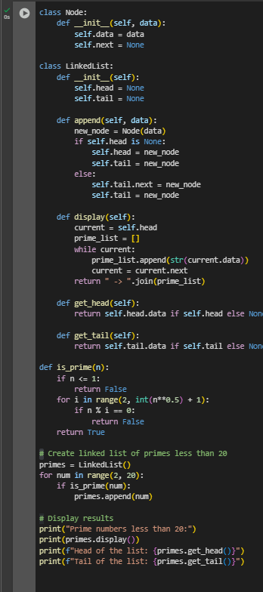

Figure 1: screenshot of the source code.

Figure 2: screenshot of the output.

Data Analysis

The program successfully identified all prime numbers less than 20, which is consistent with mathematical definitions of prime numbers . The linked list data structure provides an efficient way to store and traverse these values while maintaining the order of insertion.

The head of the list contains the smallest prime number (2), which is also the only even prime number. The tail contains the largest prime number in our range (19). This arrangement is expected since we iterated through numbers in ascending order.

Time Complexity Analysis

The algorithm has a time complexity of O(n√n) for prime checking, where n is the upper limit (20 in this case). For each number, we check divisibility up to its square root, which is an efficient method for prime identification .

The space complexity is O(k), where k is the number of primes found, as we only store the prime numbers in our linked list.

# Conclusion

In the end, this exercise was more than just generating a list of numbers; it was about understanding how we can breathe life into abstract data concepts. By building a linked list from the ground up to house these mathematical primes, we moved from theory to practice, creating a functional digital structure that organizes information with both elegance and purpose, much like the foundational principles of mathematics and computer science that quietly power so much of our modern world.

**References**

[1] Co Arthur O.. “University of Caloocan City Computer Engineering Department Honor Code,” UCC-CpE Departmental Policies, 2020.

[2] J. R. Goldman, *The Queen of Mathematics: A Historically Motivated Guide to Number Theory*. A K Peters, 1997.

[3] T. H. Cormen, C. E. Leiserson, R. L. Rivest, and C. Stein, *Introduction to Algorithms*, 3rd ed. MIT Press, 2009.

[4] N. Koblitz, *A Course in Number Theory and Cryptography*, 2nd ed. Springer-Verlag, 1994.